8/28/2017

Abstract
The abstract is a concise statement of the significant contents of your project. The abstract should be one paragraph of between 150 and 500 words. The abstract is not indents.

Keywords: list 3 to 5 keywords that describe your project.

Disclaimer
Your sponsor may require a disclaimer on the report. Especially if it is a government sponsored project or confidential project. If a disclaimer is not required delete this section.

Acknowledgement
These remarks thank those that helped you complete your senior design project. Especially those who have sponsored the project, provided mentorship advice, and materials. 4

- Paragraph 1 thank sponsor!
- Paragraph 2 thank advisors.
- Paragraph 3 thank those that provided you materials and resources.
- Paragraph 4 thank anyone else who helped you.

Table of Contents
Abstract ii
Disclaimer iii
Acknowledgement iv
List of Tables vii
List of Figures viii
Notation ix
Chapter One: EML 4551C 1
1.1 Project Scope 1
1.2 Customer Needs 1
1.3 Functional Decomposition 1
1.4 Target Summary 1
1.5 Concept Generation 1
Concept 1. 1
Concept 2. 1
Concept 3. 1
Concept 4. 1
Concept n+1. 1
1.6 Concept Selection 2
1.8 Spring Project Plan 2
Chapter Two: EML 4552C 3
2.1 Spring Plan 3
Project Plan. 3
Build Plan. 3
Appendices 4
Appendix A: Code of Conduct 6
Appendix B: Functional Decomposition 7
Appendix C: Target Catalog 8
Appendix A: APA Headings (delete) 8
Heading 1 is Centered, Boldface, Uppercase and Lowercase Heading 8
Heading 2 is Flush Left, Boldface, Uppercase and Lowercase Heading 8
Heading 3 is indented, boldface lowercase paragraph heading ending with a period. 8
Appendix B Figures and Tables (delete) 9
Flush Left, Boldface, Uppercase and Lowercase 10
References 11

List of Tables
Table 1 The Word Table and the Table Number are Normal Font and Flush Left. The Caption is Flush Left, Italicized, Uppercase and Lowercase 10

List of Figures
Figure 1. Flush left, normal font settings, sentence case, and ends with a period. 9

Notation
A17 | Steering Column Angle
A27 | Pan Angle
A40 | Back Angle
A42 | Hip Angle
AAA | American Automobile Association
AARP | American Association of Retired Persons
AHP | Accelerator Heel Point
ANOVA | Analysis of Variance
AOTA | American Occupational Therapy Association
ASA | American Society on Aging
BA | Back Angle
BOF | Ball of Foot
BOFRP | Ball of Foot Reference Point
CAD | Computer Aided Design
CDC | Centers for Disease Control and Prevention
CU-ICAR | Clemson University - International Center for Automotive Research
DDI | Driver Death per Involvement Ratio
DIT | Driver Involvement per Vehicle Mile Traveled
Difference | Difference between the calculated and measured BOFRP to H-point
DRR | Death Rate Ratio
DRS | Driving Rehabilitation Specialist
EMM | Estimated Marginal Means
FARS | Fatality Analysis Reporting System
FMVSS | Federal Motor Vehicle Safety Standard
GES | General Estimates System
GHS | Greenville Health System
H13 | Steering Wheel Thigh Clearance
H17 | Wheel Center to Heel Pont
H30 | H-point to accelerator heel point
HPD | H-point Design Tool
HPM | H-point Machine
HPM-II | H-point Machine II
HT | H-point Travel
HX | H-point to Accelerator Heel Point
HZ | H-point to Accelerator Heel Point
IIHS | Insurance Institute for Highway Safety
L6 | BFRP to Steering Wheel Center

Chapter One: EML 4551C

1.1 Project Scope
Team 507 will be working with Cummins to develop a battery module cooling concept for hybrid vehicles with pouch cell batteries. Our goals, markets, assumptions and stakeholders are all outlined below.
1.1.1 Project Description
One of the limiting factors for hybrid vehicles is the amount of heat that the battery releases during long use and rapid acceleration. This can cause the battery pack to overheat resulting in decreased performance and risk of fire. . Team 507 has been tasked with developing a concept that can efficiently cool hybrid vehicle pouch cell modules. The cooling method should cool the module at least 5% more efficiently than the current industry standard without any substantial change in production costs. The design will be based on the Nissan Leaf battery module but should be applicable to other hybrid vehicles battery modules as well.
1.1.2 Key Goals
Our goals for this project are based on improving preexisting battery pack performance benchmarks. We are not aiming to reinvent the battery pack from the ground up. We simply want to explore methods we can use to modify the battery modules in order to reduce the energy required to cool the battery pack. Our first goal is to reduce the energy required to cool a battery pack by 5%, making the cooling system more efficient. The second goal is to avoid substantial increases in production and ownership costs. The third goal of our project is that our design must withstand thermal cycling, shock and vibration, and be chemically inert. Our fourth goal is to keep the battery pack temperature within efficient operating range during operation. Our fifth goal is to follow all state and federal regulations for safe battery operation and testing. The final goal of our project is to produce a design that focuses on innovation to battery cooling at the module level.
1.1.3 Markets
Our primary markets include car companies that develop hybrid vehicles and battery manufacturers. Our main goal is to find a method to cool a battery that will go into a hybrid vehicle, so hybrid manufacturers will directly benefit from our design. Battery manufacturers can also use our method to make their batteries more efficient. Our secondary markets include car companies that develop fully electric vehicles as well as environmental organizations. While our design is for hybrid vehicles, fully electric vehicle manufacturers can draw inspiration from our design and use it to cool electric vehicles. Environmental organizations are included because better efficiency in batteries will lessen the need for fossil fuels, leading to a decreased carbon footprint. The last market that our project will include is the electronics industry. All electronic components produce heat and must be kept within specific temperature ranges. Our project can be applied to other electronic components, which means companies involved in the electronics industry will benefit from our design.
1.1.4 Assumptions
The assumptions that we made to refine the scope of our project are as follows. It is assumed that the battery that we will be using to base our design on the Nissan Leaf lithium ion pouch cell battery module. It is also assumed that a physical battery pack cannot be opened past the module level during our work due to safety concerns. Opening a lithium-ion battery past the module level becomes very dangerous as there are chemicals and fire hazards. The third assumption that we made is that the battery will be subjected to a variety of operating conditions during its use. Car batteries are subjected to many weather conditions such as extreme hot and cold as well as rain and snow. Our design must take these conditions into account. The last assumption that we made for our project is that the domain of our project is confined to the inside of the battery pack. Our scope does not include accounting for components outside of the battery pack such as radiators and fans for heat dissipation.
1.1.5 Stakeholders
The stakeholders that Team 507 has are Cummins, Dr. McConomy, Dr. Juan Ordonez, Dr. Michael Hays, and the FAMU-FSU College of Engineering.
Cummins is the sponsor for our project and will provide funding and advising for our project. Cummins is looking to implement our design into the development of new hybrid vehicles if we meet the goals that we have set for our project. Dr. Michael Hays is our Cummins advisor and will be overseeing our project.
Another stakeholder for our project is Dr. McConomy. Dr. McConomy is our senior design professor and oversees our project and provides advice and feedback throughout the design of our project.
Dr. Juan Ordonez is the faculty advisor for our project. Dr. Ordonez specializes in heat transfer, advanced power systems, fuel cells, and heat exchanger design cooling of electronics. Dr. Ordonez will provide advice throughout the project to ensure that our design can meet our goals.
Our last stakeholder is the FAMU-FSU College of Engineering. We represent the FAMU-FSU College of Engineering through our project and the success of our project shows the education, preparation, and engineering knowledge that the college instils in its students.

1.2 Customer Needs
Team 507 is working on designing a method to improve cooling in Lithium-Ion batteries in Hybrid vehicles by 5% over current industry benchmarks. Our sponsor for this project is Cummins and they will also serve as our customer for the project since we are designing our project for their use. We asked our point of contact at Cummins questions to develop our customer needs and recorded his responses. These responses were then interpreted into customer needs that we will use to guide our design.

Question | Customer Statement | Interpreted Need
- Should we be expected to design below the module level of the battery? | A scaled model of battery pack using pouch cells can be made with heating packs as a heat source. | The cooling design has the ability to be applied within the battery modules.
- What is the biggest risk of failure for a battery or pouch cells? | The biggest risks to battery pouch cells are thermal runaway then puncture. | Cooling design lowers risk of thermal runaway while avoiding puncture to pouch cells.
- Is there a limit to additional weight we can add to the battery pack? | The enclosure can weigh 20% of the module, 80% of the mass of the module should be the cells. | Design components other than pouch cells are less than 20% of weight of the battery module.
- Can we rearrange or redesign the layout of the modules? | We are designing the module, so yes. | The cooling design implements rearrangement or redesigning of the module configuration to improve cooling.
- Do we need to consider extreme outside temperatures that a battery could be subject to? | Consider ambient temperatures between –40 C to 40 C. Transmission tunnels can get up to 105 C and the outside frame rails can get to 85 C. | Cooling design performs effectively in extreme temperatures that would cause damage to the battery.
- Should our design be implementable into all types of vehicles? | Focus on heavy duty North American Class 8 vehicles. | The cooling design has ability to be implemented to North American Class 8 hybrid vehicle battery packs.
- Should our design be focused on both steady state and transient conditions during battery usage? | Yes, consider transient conditions. Reject heat up to C rates of 10. | Cooling design has the ability to withstand high rates of heat transfer during transient conditions.
- Do we need to incorporate our design into the battery’s Battery Management System? | Only incorporate the temperature probes from the battery’s Battery Management System. | Cooling design detects cell temperature and communicates with the Battery Management System.
- Are we able to incorporate pumps and heat exchangers into the design? | The domain of the project is the enclosure of the battery pack, however if pumps are used be sure to minimize the pressure losses. | A cooling design using pumps or heat exchangers minimizes pressure losses.
Table 1: Customer Needs
Customer needs questions were gathered prior to the meeting based on the project scope we had previously discussed with the customer. Before asking the customer our questions, we revisited the project scope and asked the sponsor if everything was accurate based on our first meeting. This helped us to narrow down what questions needed to be asked and which ones had already been answered and clarified. We then began asking the customer needs questions one at a time. The questions and the customer’s answers were recorded verbatim and then we made sure that we fully understood the customer’s response before moving forward to a new question.
The customer clarified that testing a model of the battery module would be satisfactory since testing an actual battery module would present unnecessary safety risks. We narrowed down the performance needs the customer desired as well. The customer clarified that the cooling method would need to work for C rates or discharge rates up to 10 and that ambient temperatures would need to be considered in a range of –40 to 40 degrees Celsius. We also clarified what safety risks the customer wanted us to consider. The main risks would be excessive heat and battery cell puncture. We clarified that the scope of our design is the inside of the battery module. However, outside pumps and heat exchangers could be considered and may serve as an effective method for battery cooling. The only outside integration with the Battery Management System that will be considered is the temperature probes integration with the BMS.

1.3 Functional Decomposition
After talking with our sponsor, the team was able to clarify the project scope and what the customer needs for the project. Functional decomposition was utilized to interpret the needs of the project into systems, to find the necessary components that will satisfy the customer. One thing to keep in mind is that we are not breaking down all the macroscopic battery cooling functions. This is because we are not focusing on coolant pumps and systems outside the module. Our customer is allowing us to lightly consider the outer cooling systems, but he mainly would like us to focus on how cooling takes place inside the battery modules. The hierarchy chart and cross reference table below help break down the functions we are considering inside the battery modules. They serve to separate and clarify each function we must consider when developing our own cooling concepts.
Hierarchy Chart
The hierarchy chart represents the total breakdown of the cooling system. Our project is broken into four categories: Heat Transfer, Safety, Efficiency, and Controls.
The Heat Transfer system is responsible for cooling and heating the battery, the main function of the project. Safety, Efficiency, and Controls are systems that we must satisfy and consider while modifying the transfer of heat throughout the system.
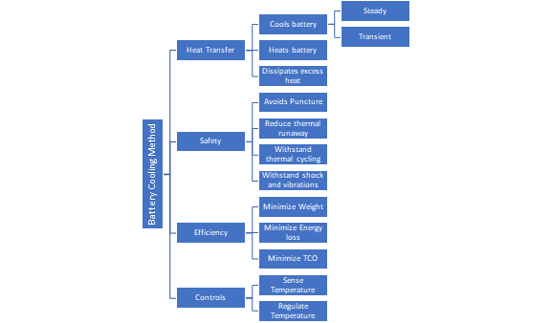
Figure 1: Function Decomposition Hierarchy
The heat transfer system must cool the battery during transient conditions to improve efficiency and maintain safety. It must also heat the battery in the case of cold weather conditions to maintain efficiency. Also, the cooling system must be able to maintain a relatively low temperature during transient conditions such as vehicle braking and acceleration (battery charging and discharging).
The safety system is related to the heat transfer system in that the cooling of the battery helps prevent battery puncture due to high heat. The safety system also includes shock and vibration resistance as these factors can also cause battery cell punctures.
The efficiency system is broken down into weight reduction, energy loss minimization, and total cost of ownership reduction. These systems are based off specific requirements clarified by the customer.
Finally, the controls system involves the communication between the battery control module and the thermal sensors in the battery. We must consider how these communicate and how the BCM reacts to temperature change within the battery.
Integration
The cross-reference table shown below was made to identify how each of the functions has an influence on different major systems. This helps to identify how each function can affect other major systems that they are not grouped under. For example, the function “Withstand Thermal Cycling” has influence on Heat Transfer, Safety, and Efficiency systems. As the battery is used, the cells in the battery will experience thermal cycling and this will impact how the design can transfer heat, how efficient the design will be, and has implications on the safety of the design. Each of the functions that falls under multiple systems provides integration between the systems. This will allow our design to meet all the aspects we are trying to meet by relating the transfer of heat to the efficiency of the design, to the safe operation of the design, and to the controls that regulate the system. The more integrated this system becomes the more functional the design will be.
Connection to Systems
The functional decomposition has four systems. These four systems represent the main groups that our design will need to meet our goals. Each of these systems has multiple functions that have influence over the overall system. For example, in the cross-reference table below almost every function has a relation to Heat Transfer. Our design’s ability to transfer heat will be influenced by each of these functions. This is expected as the main goal of our project is to remove heat from the battery. Minimizing energy loss has influence on the Heat Transfer system because heat is being transferred from the battery, we don’t want to use an inefficient amount of energy from the battery. A case was made for the influence that each of the functions has on the different systems that they relate connect to.

Table 1: Cross Reference Table
 | Heat Transfer | Safety | Efficiency | Controls
Cools Battery | X |  |  | X
Heats Battery | X |  |  | X
Avoids Puncture | X | X
Withstand Thermal Cycling | X | X | X
Withstand Shock and Vibrations |  | X
Minimize Weight | X | X | X
Minimize Energy Loss | X |  | X
Sense Temperature |  |  | X | X

Action and Outcome
Our battery cooling concept will need to consider safety, efficiency, and communication with the controls system in order to be successful. The breakdown of systems into their functions will allow us to more easily integrate all these factors into each design decision we make, and to create a concept that satisfies all our customers’ needs and requirements. To keep the battery from overheating the design must transfer heat from inside each of the modules and dissipate this heat outside of the battery. The design must do this safely as electrical fires from Lithium-Ion Batteries are very dangerous. Efficiency of the design is a major focus because taking power away from the energy to move the vehicle will decrease the range that the vehicle can achieve. A control system will be used to sense the batteries' temperature and regulate the rate that heat needs to be rejected from the battery to keep the battery in its optimal temperature range.

1.4 Target Summary

Functions and Targets/Metrics
From our functional decomposition we determined ten functions that our product must do to be functional. From each of these functions we determined how we plan to validate each of them as well as specific values that our design will need to meet. The major systems that we determined for our design are Transfer Heat, Safety, and Efficiency. From these three systems we determined each of our functions. The functions that we determined for our design were cools battery, heats battery, avoid puncture, withstand thermal cycling, minimize energy loss from pressure losses, minimize weight, and accommodate pouch swelling. Targets were introduced as a means to verify a specific number that each of our functions must meet to achieve the goals of our project. Each function has a specific target and metric that it will be measured against to verify the success of the function. Table 1 shows each of the functions that we came up with along with the metric that will be used to validate, the target value that we will use to design around, and the units of the target.
Table 1: Targets and Metrics for each Function.
Function | Target Description | Metric Description
Cool Battery | <40 [°C] | Temperature
Heat Battery | >20 [°C] | Temperature
Avoid puncture | 20 [N] | Force
Withstand thermal cycling | 2000 Cycles | Durability
Minimize weight | 1.5 [kg] | Weight
Minimize energy loss due to pressure losses | 1 [kpa] | Pressure
Accommodates pouch Swelling | 10% of cell volume [m^3] | Size

Targets/Metrics Beyond Function
The targets that we determined that go beyond our functions are shown in Table 2. These targets include keeping the cost of the design under $150, using materials that are not going to rust or fluids that will freeze, and the design must fit into a module with dimensions of 340 mm length, 230 mm width, and 50 mm height.
Table 2: Targets that go Beyond Functions
Customer Need | Target | Metric
Minimize total cost of ownership | $100 | Cost
Method is resistant to changing weather conditions | Rust and Freeze Resistant | Durability
Method adds minimal volume to the module | 340x230x50 [mm] | Size

Critical Targets and Metrics
The critical targets for this project are to cool the battery, avoid puncture to the battery cell, minimize energy loss from pressure losses, and minimizing weight. It is crucial for the developed method to cool the battery to the desired temperature. If the battery reaches too high of a temperature, then there is a heightened risk of critical failure to the battery. Thermal runaway is another risk for battery packs that must be avoided if the temperature of the cell gets too hot. Furthermore, if the battery cell for the device is punctured then there is a risk of creating a lithium fire. Beyond failure of the battery, this would cause a significant safety risk, so the developed method should not induce the risk of puncture to the battery cells. Another critical target and metric for our project is minimizing energy loss from pressure losses. If a fluid is pumped through the module a pressure loss will be generated from the friction losses within the system. Higher pressure losses require a larger pump which will use more energy from the battery pack to power it. Minimizing pressure losses is crucial for our project because it will allow our method to be more efficient. The last critical target and metric for our project is minimizing weight. A higher battery module’s weight means that the vehicle will have to move more mass. This makes the vehicle less efficient and makes the total cost of ownership of the vehicle increase.

Derivation of Targets and Metrics
To derive the cooling of the battery function we researched temperature ranges that lithium-ion pouch cells can withstand during operation. We found that these batteries need to stay under 40 °C and if they go over this temperature the battery will begin to degrade and eventually catch on fire if it continues to get hotter. To derive the target for avoiding puncture of the battery we researched how much force is required to puncture a pouch cell. We found that a force of 20N (5 lbf) is enough to puncture a pouch cell. For the pressure loss we researched how much current pressure loss current cooling plate design have. The value varied, but the most optimized pressure drop we found was around 1[kpa]. Our pressure drop target is to have a pressure drop through our system that is less than current cooling plates. Lastly for the weight of our design we researched the current industry weight of battery packs, modules, and cells. We found that on average the cells inside of a module make up approximately 80% of the module weight and the module shell and cooling systems make up about 20%. From there we calculated that for a four-cell module design the entire weight would be approximately 8kg. Taking 20% of this value gave us a design weight of 1.5[kg].

Method of Validation and Measurement
To test the cooling of the battery with our design we are going to use heating pads. Since we can’t use real lithium-ion pouch cells due to safety concerns, we are going to use heating pads that produce the same amount of heat flux that the pouch cells would when they are being discharged. From there we will use a temperature sensor to monitor the temperature of the battery module at different locations to see if our design keeps the temperature of the module under the target value. To test the pressure drop within the design we will need to use a pressure sensor at the inlet and the outlet of the coolant passage and determine the difference in the pressure at the two points. This is a key test for our design because the efficiency of the design is important in determining if the design improves upon existing cooling methods. To validate the weight of the design we will use a scale to measure how much it weighs. This measurement will be an empty design with no heating pads inside of it.

1.5 Concept Generation
Concept generation is an important tool to use for finding a solution to a problem. Our team utilized multiple concept generation techniques to generate one hundred concepts. An abundance of concepts makes it more likely that we have looked at all possible ideas and the best concept can be selected during concept selection. The list of all 100 concepts is shown in appendix D. From our list of 100 concepts 5 were chosen to be medium fidelity concepts, meaning that they could be suitable solutions for our project and 3 concepts were chosen as high fidelity concepts which means they have the prospect to fulfill a majority of the needs of our design.
1.5.1 Concept Generation Tools
Generating the one hundred concepts required the use of numerous techniques including: brainstorming, crap shoot, and biomimicry. General brainstorming resulted in approximately forty percent of the total concepts. In brainstorming, we wrote whatever came to mind, both orthodox and unorthodox methods were welcomed. The next method was crap shoot, here we investigated entirely improbable designs but could possibly yield valuable solutions. This method did not result in many concepts but made it interesting to look at our problem with an open mind. The last method we used was biomimicry, we searched keywords like cooling and found examples of cooling in nature. One example of biomimicry is concept number 48 which entails drilling holes in the module walls to increase air flow within the module. This idea came from research that we found about how termites drill holes in their nest to increase cooling. Another example of biomimicry that we used as inspiration was sweat. Sweat is how mammals cool themselves by releasing water which carries heat out of the body. This inspired concept number 15 which is using a salt hydrate-based phase change material to cool the cell. As the cell heats up the phase change of the material occurs which absorbs the heat and moves it outside of the cell.
1.5.2 Medium Fidelity Concepts
After completing our list of 100 concepts our team went through the list and picked out ideas that we felt were medium fidelity concepts. This included ideas that we felt offered solutions to aspects of our project that can be useful design but did not encapsulate all the functions that our design needs to have. Table 4 shows the list of medium fidelity ideas we produced.
Table 4: Medium Fidelity Concepts
Concept Number | Description
12 | Cooling plates sandwiched between modules with coolant flowing between them.
15 | Using salt hydrate phase change materials to absorb heat and remove it from inside of the module.
45 | Coolant channel that starts at the top of the module and snakes between all the cells and outputs to a heat sink at the bottom of the module.
53 | Cabinet based holding for pouch cells with gap in between each cell to allow for coolant flow.
55 | Angle slits on the battery pack to increase the amount of airflow into the modules

1.5.3 High Fidelity Concepts
From the list of 100 concepts three were chosen as high fidelity concepts. These concepts are shown in Table 5. These concepts have many of the functions that our design will need to meet our targets.
Table 5: High Fidelity Concepts
Concept Number | Description
22 | Route liquid cooling pipes around the inner shell of module wall with aluminum plates between cells to transfer heat to pipes.
44 | Create thermal paste packs that increase contact area between cells and module walls.
54 | Layer highly thermally conductive tape between cells to transfer heat to the side of the module to which the coolant channels are connected.

Concept 22 is routing liquid cooling pipes around the inner shell of the module walls with aluminum plates between the cells to transfer heat to the coolant pipes. This concept takes advantage of liquid cooling to provide more heat transfer within the cell. The specific heat of fluids such as water are much higher than air. Also, routing the cooling pipes around the module gives the pipes more space which will allow them to have a larger diameter which will reduce the pressure drop within the pipes. The use of the aluminum plates will allow the heat from each cell to transfer in multiple directions to reach a pipe, keeping the temperature gradient across the cell constant. If higher heat transfer is needed the fluid flow rate can be increased to improve heat transfer within the module.
Concept 44 uses thermal paste packs to increase contact area between the cells and module walls. The more surface area there is between the cells and the cooling medium allows for more heat to be transferred within the cell. Thermal pastes have a high thermal conductivity which will efficiently remove heat from the module. Thermal paste will be able to maximize the empty spaces within the module that would normally be filled with air.
Concept 54 uses thermally conductive tape between cells to transfer heat to the sides of the module. Thermally conductive tape is used in electronics such computers to remove heat. This design will utilize this thermally conductive tape to efficiently transfer heat from the cells to a coolant channel. One advantage of this concept is the tape is very light and has a high thermally conductivity. It also allows the design to significantly reduce pressure drop from coolant channels because the tape limits the need for coolant channels within the module.

1.6 Concept Selection
House of Quality
The first step that we took during our selection process was to create weights for each of
our customers' needs so we could determine the importance weight factors. We did this using the binary pairwise comparison chart in Figure 1. The customer requirements are listed in the rows, and we went cell by cell comparing each row to the column that corresponds to that customer
requirement. If the row requirement was more important than the column requirement the cell
was given a 1 and it was less important compared to the column the cell was given a 0. The total
across each row was calculated and this value corresponds to the weight for that customer
requirement. Keeping the temperature of the module under the required operating temperature had the highest importance weight factor.
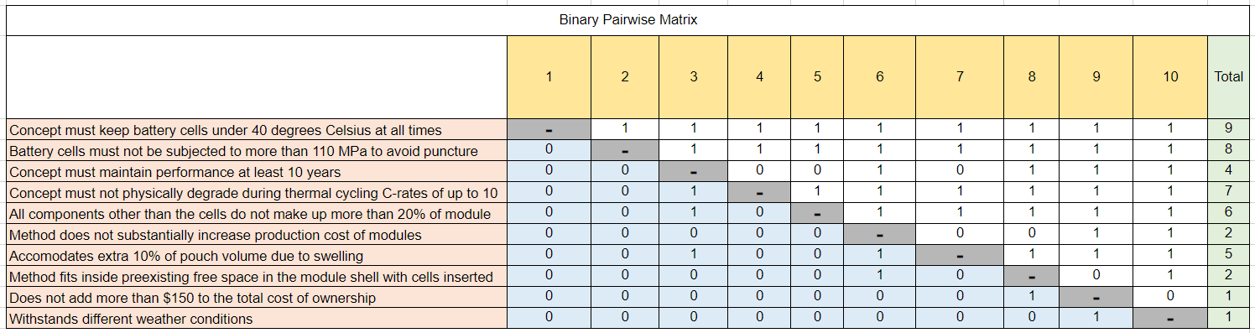Figure 1: Binary Pairwise Comparison of Customer Needs

The importance weight factors calculated using the binary pairwise comparison were then entered into the House of Quality presented in Figure 2. Our customer requirements are listed in
the rows, and the engineering characteristics are listed in the columns of the table. The
engineering characteristics were determined from our functions and targets. We went row by row and determined if the engineering characteristic would contribute to fulfilling the customer
requirement. A value of 9 was given if the engineering characteristic significantly contributed, a
3 was given if it moderately contributed, a 1 was given if it slightly contributed, and no value
was given if it did not contribute at all. A score was then calculated for each engineering
characteristic. From the relative weights of the engineering characteristics, we determined that
the most important characteristics were the ones that had a relative weight greater than 10%.
The outcome of the House of Quality chart was that the engineering characteristics that we would use as decision making criteria were temperature, avoiding puncture, thermal cycling, accommodates swelling and minimizing total cost of ownership. These decision-making criteria were then used to evaluate the Pugh chart and analytical hierarchy process.
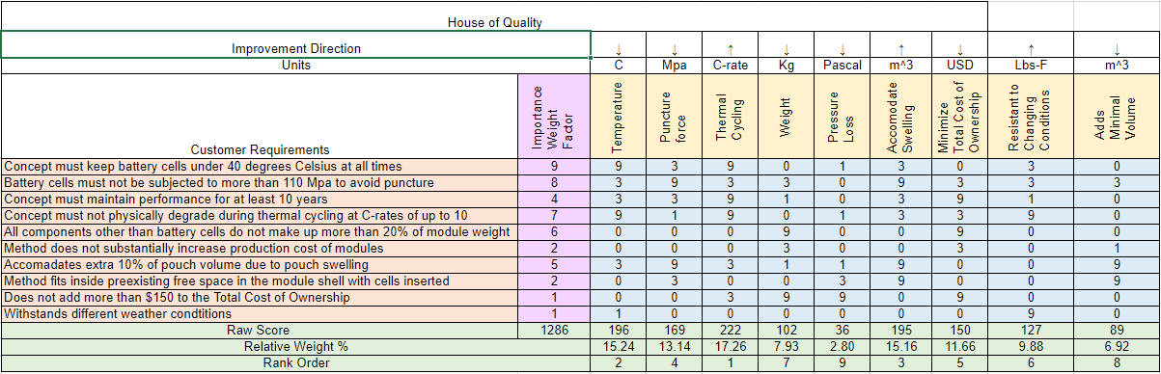Figure 2: House of Quality

Pugh Chart
Using the engineering characteristics that were determined to be most important to our design we utilized a Pugh chart to compare our top concepts to a datum. The datum that we compared our concepts to was the Nissan Leaf module. The Nissan Leaf uses an air-cooled battery pack with cooling tabs between the modules to transfer heat out of the modules to the ambient air. We compared the medium and high-fidelity concepts shown in Table 1 using the Pugh Chart shown in Figure 3. The criteria that is better than the datum was given a +, the criteria worse than the datum was given a -, and the criteria that performs the same as the datum was given an S. Each concept was compared, and the number of pluses and minuses were totaled. From here we moved forward with the concepts that had the most pluses and least minuses.

Table 1: Medium and High-Fidelity Concepts
Abbreviation | Concept Description
Phase Change | Using salt hydrate phase change materials (PCM) to absorb heat
Plates between Modules | Cooling plates in between modules with coolant flowing between them
Cabinet Cooling | Cabinet based holding for pouch cells with gap in between each cell to allow for coolant flow
Channel Snake between Cells | Coolant channel that snakes between the cells and outputs to a heat sink
Angle Slits | Angle slits on the battery pack to increase the amount of airflow into the modules
Cooling Pipes Inner Shell | Route liquid cooling pipes around the inner shell of module wall with aluminum plates between cells to transfer heat to pipes.
Thermal Paste | Create thermal paste packs that increase contact area between cells and module walls
Conductive Tape | Layer highly thermally conductive tape between cells to transfer heat to the side of the module to which the coolant channels are connected

From the initial Pugh chart in Figure 3 it was determined that the concepts that would move on to the next Pugh chart was the Cabinet Cooling, Cooling Pipes on Inner Shell, Thermal Paste, and Conductive Tape. The channel snake between cells had a high number of plusses and minuses, so it was chosen as the datum for the next Pugh chart. The Phase change and angle slits concepts were eliminated due to having the least number of pluses. These two concepts had a lot of satisfactory marks meaning they would perform similar to the Nissan Leaf cooling system.

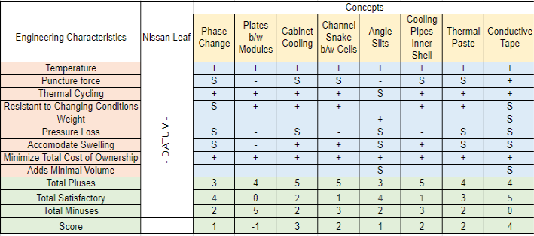
Figure 3: Initial Pugh Chart
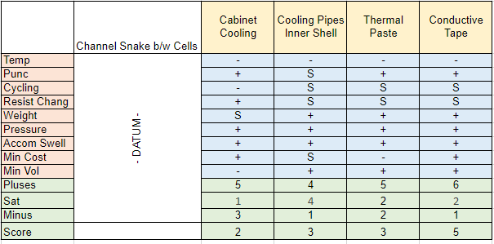
Figure 4: Top Concepts Pugh Chart
We set our medium fidelity concept Channel Snake between the cells as our datum for the final Pugh chart. Figure 4 shows the second Pugh chart that was used to compare the final four concepts to the new datum. After comparing the concepts to the new datum, it was determined that conductive tape (concept #54) was the best design followed by thermal paste (concept #99) and cooling pipes inner shell (concept #22). In the final Pugh chart, the conductive tape has the most pros, the only con is that it does not cool as much as the datum. The cooling pipe method satisfies most of the needs with very few cons, but the thermal paste is more resistant to puncture, which is why they tie for second best concept. After reviewing the final pugh chart, cabinet cooling will be ignored for its added volume and not being resistant to thermal cycling. The Cabinet Cooling option had the highest number of minuses in key areas such as temperature, adds minimal volume, and withstanding thermal cycling. The three remaining concepts that were moved forward to the analytical hierarchy process were the thermal paste, cooling pipes inside inner shell, and thermally conductive tape concepts.

Analytical Hierarchy
An analytical hierarchy process was used to first determine the importance of each engineering characteristic to the project. Each characteristic was weighed against each other to see which one was more important. If the characteristic was determined to be more important to the project it would receive a higher score, such as a 5 or 7. Otherwise it would receive a lower score, such as 0.2 or 0.3. Figure 5 shows the overall scores of each characteristic, and its normalized chart to show which one came out most important.
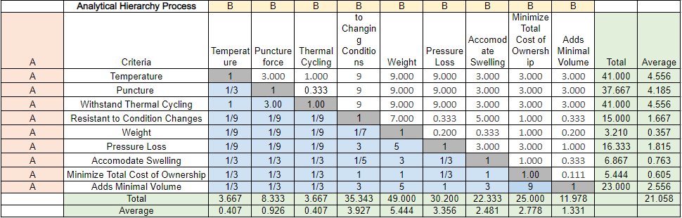
Figure 5: Comparison Matrix of Engineering Characteristics
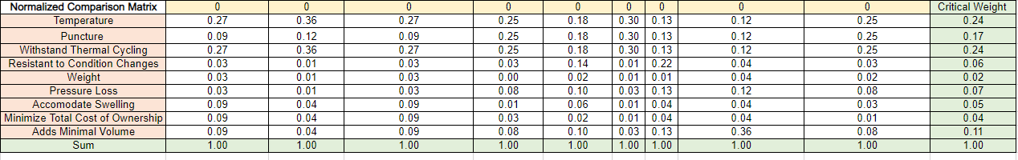Figure 6: Normalized Engineering Characteristic Comparison Matrix
After going through the process, it was found that the temperature and withstand thermal cycling characteristics were the most important to the success of the project. Puncture and adding minimal volume to the module were also found to be important to the project, though not as much. After that, the three best concepts that were determined through the pugh chart were weighed against each other to determine which concept would best meet the critical characteristics. If a concept was determined to more successfully meet the characteristic, then it would receive a higher score, similar to the scoring done for the comparison matrix. Those values were then put into the final selection table so that each score could be compared. It was found that the cooling pipes concept scored the highest in the temperature and withstand thermal cycling characteristics while the conductive tape concept scored the highest in the other two categories. Figure 7 shows the final selection table that has the scores for each concept.
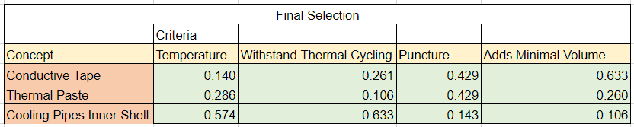Figure 7: Final Selection Table
This table was then used to find our alternative value table, seen in Figure 8, that would ultimately show which concept is the best. The alternate value table shows that the cooling pipes with inner shell concept was the highest score and is the concept that the team will move forward with.
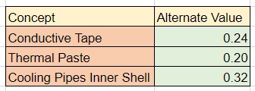
Figure 8: Alternate Value Table
Selection
After analyzing the Analytical Hierarchy Process the cooling pipes on inside of module shell was determined as the winner and the concept that our team will move forward with. This concept (Concept #22) involves routing liquid cooling pipes around the inner shell of the module walls with aluminum plates between the cells to transfer heat to the coolant pipes. This concept takes advantage of liquid cooling to provide more heat transfer within the cell. The specific heat of fluids such as water are much higher than air. The fluid that will be used for our final design has not been determined yet but one option that we have investigated is a glycol water mixture. Also, routing the cooling pipes around the module gives the pipes more space which will allow them to have a larger diameter which will reduce the pressure drop within the pipes. The use of the aluminum plates will allow the heat from each cell to transfer in multiple directions to reach a pipe, keeping the temperature gradient across the cell constant. If higher heat transfer is needed the fluid flow rate can be increased to improve heat transfer within the module. This design will take advantage of wasted space around the module walls where the pouch cells do not contact each other. Figure 9 shows a sketch of the design. There will be a supply line that connects the cool coolant to the module. From the connection the fluid will split off into each of the cooling pipes. The pipes will wrap around the outside of the module collecting heat from the aluminum plates that are between the cells. The fluid will join back at the outlet and then go into a return line. The aluminum plates between the cells will be joined with the cooling pipes so that the heat can transfer from the plates to the fluid.

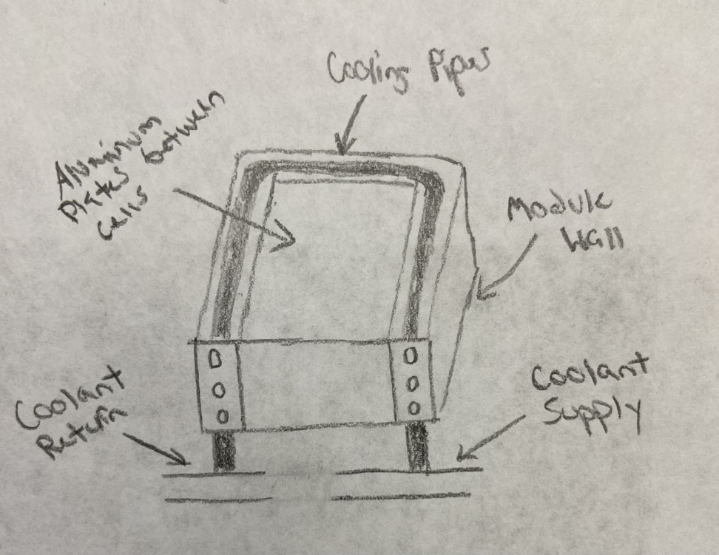
Figure 9: Final Selection Sketch

1.8 Spring Project Plan

Chapter Two: EML 4552C

2.1 Spring Plan

Project Plan.

Build Plan.

Appendices

Appendix A: Code of Conduct
Mission Statement:
Our goal is to use our collective engineering knowledge to provide innovative solutions at the highest level for our customer. We will work in a professional manner keeping the values and needs of the customer at the center of our work. We will work together at the best of our capabilities to provide engineering innovation to our customer in order to accomplish this goal.
Outside Obligations:
• Anthony -
Work Monday and Wednesday. All day.
• Jacob -
Work Tuesday, Wednesday & Thursday 10am-2pm, Saturday all day, Sunday until noon. Class Tuesday and Thursday 8am-9:25am.
• Clayton Carlson -
Work Tuesday, Thursday 8am-3pm, Works Friday all day. Class Monday 8am-9:15 and 3:30pm-4:45pm.
- Chris Carley – Class Monday and Wednesday 8am-9:15am, Tuesday and Thursday 9:30am-10:45am, Wednesday 2pm-3:45pm.
- Corey Kelly – Class Tuesday and Thursday 11am-12:15pm, Recitation Friday (Time unknown)
Team Roles (Subject to change):
• Jacob Owens - Manufacturing Engineer: Tasks include taking CAD models and making detailed drawings with comments to give machinist for proper manufacturing of the design. This also includes meeting and staying in direct contact with the machinist to discuss problems and give/recieve feedback on the manufacturing of the design. Tasks also include coming up with solutions to manufacturing issues and researching outside companies that can manufacture our design if the machine shop is unable to.
• Clayton Carlson -Design Engineer: Task include making CAD Design and ComSol simulations. CAD designs must have precise measurements and look neat and detailed. Designs must fit the constraints of the module and pouch cells that are being used for the project. Comsol simulations must accurately simulate the heat transfer and fluid dynamics of the design.
• Chris Carley - :Materials Engineer: Tasks include researching materials and parts that are required for the design. The Materials Engineer will work closely with the Manufacturing Engineer to determine materials that are needed for manufacturing the design. Other tasks include ordeirng and keeping track of when different parts arrive. Materials Engineer shall help determine all materials and parts that will be needed for testing and validation.
• Corey Kelley - Systems Engineer: Tasks of the Systems Engineer include making sure project operates as a whole. The Systems Engineer is responsible for making sure parts fit together and operate correctly before they are ordered. They will also be responsible for making sure validation methods are achievable and coordinating testing and validation efforts.
• Anthony Vicary - Heat Transfer Engineer: Tasks of the Heat Transfer Engineer include providing solutions to the heat transfer aspects of the design and making improvements to the heat transfer capabilities of the design. The Heat Transfer Engineer will work closely with the Design Engineer on CAD models and Comsol Simulations.

Other tasks not included in the roles listed above will be assigned to group members by entire team based on current project workload, member expertise with specified task, and task priority as it relates to project status. The team will work together to distribute other tasks in a fair and appropriate manner. Team will have no specified leader. All group members hold equal weight on all decisions and issues throughout the project.
Communication:
Communication between team members will mainly be done through the group message in Groupme. Any formal communication with the sponsor will be done through school emails or the decided upon video meeting platform. Team members are required to respond to all messages or emails directed at them within 24 hours. All group assignments must be reviewed by all team members before a submission can be posted. Scheduling will be done using When2meet. Team members will enter times when they are unavailable to meet, and a group will use the calendar to find a time that works for all members.
Attendance:
All group members must attend meetings with the sponsor. If someone has a valid reason for having to miss a sponsor meeting, it must be communicated with the group before the meeting is held. If the team decides to meet to work on the project during a time that a group member has an outside obligation listed in this form, the group member should not be expected to attend. Group members will attend all in-class lectures unless they have a valid reason for missing a lecture. If a group member misses a meeting or scheduled work time without notifying the other members, the group will determine the work that was missed by that member and will be required to finish that work on their own time. If a group member misses three scheduled meetings or work times without notification, the group will have a meeting to discuss how to move forward.

How to Notify Group:
If unable to attend a meeting or work session, a group member should notify the group either by email or the group chat at least 24 hours before the scheduled meeting or work session. Professional Meetings: Meetings with the sponsor will be held in a professional manner. All group members are expected to be ready to meet at least 5 minutes early. Meeting minutes will be kept, and notes taken by all group members. These notes and minutes will be condensed and organized for future meetings and work. A single group member will be chosen to briefly update the sponsor on the work that has been done since the previous meeting and the current state of the project at the beginning of each meeting.
Dress Code:
• Meetings/Video meetings - Business casual (Button-up dress shirt or nice collared shirt, no hats or jewelry).
• Project presentations - White button up shirt with khakis or dress slacks. Ties are optional for in-class presentations.
• Senior design day - Suit and tie with dress shoes.
How do We Attempt to Solve Problems Before Contacting Dr. McConomy?
All group members discuss the problem either in person or in the group message and attempt to reach an agreement. If a solution cannot be reached a vote can be requested by any group member on any issue and the majority vote will decide the outcome.
At What Point Do We Contact Dr. McConomy?
If an agreement cannot be reached through discussion or a vote, we will reach out to a T.A. If an agreement cannot be reached with the T.A.’s help, then we will reach out to Dr. McConomy.

What Do We Ask of Dr. McConomy When Going to Him to Resolve an Issue?
We ask that he provides his recommendation on how we should move forward so that we can discuss and resolve the situation as a group.
How Do We Amend This Code of Conduct?
To amend the code of conduct a vote must be held and 4 out of 5 members must agree on an amendment. An amendment to the Code of Conduct may be brought forth at any point during the project. Statement of Understanding By signing below, you acknowledge that you have read the code of conduct and agree to follow it throughout the course of this group senior design project.
Statement of Understanding:
By signing below, you acknowledge that you have read the code of conduct and agree to follow it throughout the course of this group senior design project.

Appendix B: Functional Decomposition

Appendix C: Target Catalog

Function | Target Description | Metric Description
Cool Battery | <40 [°C] | Temperature
Heat Battery | >20 [°C] | Temperature
Avoid puncture | 20 [N] | Force
Withstand thermal cycling | 2000 Cycles | Durability
Minimize weight | 1.5 [kg] | Weight
Minimize energy loss due to pressure losses | 1 [kpa] | Pressure
Accommodates pouch Swelling | 10% of cell volume [m^3] | Size
Minimize total cost of ownership | $100 | Cost
Method is resistant to changing weather conditions | Rust and Freeze Resistant | Durability
Method adds minimal volume to the module | 340x230x50 [mm] | Size

Appendix D: Concept List
- Use peltier device within module to help generate electricity without raising temperature
- Change layout of cooling channels to reduce losses
- Make use of copper's high conductivity to take away more heat
- Make use aluminums high conductivity to take away more heat
- Reduce the distance between plates to increase the heat rate
- Add fans to induce airflow into the module to increase the heat taken out
- Add more cooling plates to the module
- Add fins to the cooling plates with induced airflow to increase heat taken out
- Increase the amount of cooling channels to increase heat taken out
- Increase the area of the cooling plate to increase heat taken out
- Decrease the thickness of the cooling plates to increase heat taken out
- Cooling plates in between modules with coolant flowing between them
- Add holes/slits in battery pack to allow for increased airflow
- Increase the convection heat transfer coefficient (h)
- Using salt hydrate phase change materials (PCM) to absorb heat
- Using paraffin PCM to absorb heat
- Heat pipe design with an air-cooled end
- Heat pipe design coupled with coolant flow
- Submerge the cells in coolant Batter
- Submerge module in ice pack
- Put batteries inside the vehicle and place them in a refrigerator
- Route liquid cooling pipes around the inner shell of module wall.
- Add carbon fiber plates between cells to increase conduction from cells.
- Add cooling plates between each cell and run coolant through the plates.
- Pump antifreeze over the modules when they overheat
- Coolant is run through a fan cooled radiator
- Use lightweight material so less energy is required to operate the vehicle
- Use evaporative cooling method
- Use aluminum foil sheets to increase the contact area of cooling
- Use heat sink to force heat out
- Spray coolant onto cells onto cells and cooling plates
- Add AC system to battery pack
- Tilt batteries and spray coolant, allow for coolant to run down modules and fall to bottom of pack, pump waste out
- Spray coolant on batteries intermittently and let coolant pool on bottom, add cooling element to the pooled coolant and slowly pump it out
- Placing pack on cooling/heating pad
- Submerge module in coolant, constantly pumping in cool coolant while pumping out hot coolant
- Submerge module in coolant while constantly cooling the pool
- Serpentine pipes between modules
- Insert dry ice into modules before each use
- Have a bunch of tiny fans blowing
- Single cooling pipe that goes around module with aluminum plates to transfer heat to the fluid
- Cold plates with dimples inside induce turbulence on flow to increase conduction
- Thermally conductive tape between cells used in electronics to transfer heat
- Create thermal paste packs that increase contact area between cells and module walls
- Coolant channel that snakes between the cells and outputs to a heat sink
- Cooling plate with entire plate filled with coolant instead of using pipes
- Energy is pulled from other sources when the batteries overheat
- Drilling holes in the module walls to increase natural convection
- Plate heat exchanger that has the cells fitted between it and fluid flows through it
- Diamond plated heat exchanger
- Gold plated heat exchanger
- Cabinet based holding for pouch cells with gap in between each cell to allow for air flow
- Cabinet based holding for pouch cells with gap in between each cell to allow for coolant flow
- Layer highly thermally conductive tape between cells to transfer heat to the side of the module to which the coolant channels are connected
- Angle slits on the battery pack to increase the amount of airflow into the modules
- Using AC pump to provide cold air to the modules, similar to building hvac
- Use insulation to conserve cool air, then extract hot air through holes in the top
- Air compressor on vehicle compresses air and as air is released into the module and the drop in pressure reduces temperature in air going into module
- Add scoops to battery pack to increase the amount of airflow
- Use silver plates between the cells to transfer heat at a higher thermal conductivity
- Use a hydrogel of a polyacrylamide framework infused with water and specific ions. When hydrogel is heated, electricity is produced creating less strain on the batteries.
- Decrease the surface roughness of cooling channels to minimize losses
- Cells are immersed in a dielectric fluid and the fluid absorbs the heat as the battery cells heat up
- Increase the diameter of the cooling channels to reduce losses
- Switching the side of the tabs of the cell so they are on opposite ends of the battery module.
- Use liquid nitrogen heat exchanger to cool battery
- Use liquid helium for better efficiency and to cool the battery
- Bring outside airflow into a radiator inside the battery pack
- Intermittently drop dry ice into pack during operation
- Use cooling plates with modules submerged in a cold pool of liquid
- Route heat from cooling plates to battery pack and have outside airflow cool battery
- Add fins to battery pack
- Submerge battery pack in coolant
- Spray coolant on battery pack
- Use regular cooling plates and spray extra cold coolant into the network when heat is too extreme
- Use a fan to blow evaporated liquid nitrogen into the module
- Have a rotating cold plate, as one plate gets hot rotate in one that has been precooled
- Focus cooling on one part of the cell so that it overall doesn’t overheat
- Connect cooling channels to fins on the battery pack and route them into the cooling plates in the module
- Use shell and tube heat exchanger to help direct air and coolant flow to effectively cool cells
- Submerge battery pack in cold pool and insulate the pool, have hot liquid circulated out and cooled using outside airflow and bring it back into the pool
- Use barbed pipes to increase the surface area of the pipes and increase the amount of heat taken out
- Periodically pour coolant onto cells
- Put cells on rotating piece that dumps them into coolant as the piece rotates
- Put cells on rotating piece that dumps them into coolant as the piece rotates and spray coolant onto the cells at the top of the rotation
- Use baffles to prevent the cooling channels from vibrating and losing energy
- Spread cells out with one cooling plate per cell
- Decrease the length of cooling channels but increase the number of passes
- Use smoother cooling channels to decrease losses
- Have sliding piece in module that goes to each cell spraying coolant
- Pour coolant onto cells, have it pool at the bottom, as it gets hot pump it out and recool It
- Use smoother channels with higher damping on the battery to decrease losses
- Have coolant injectors on a rail in the module that intermittently spray coolant
- Use a sprinkler type system that can spray the whole module with coolant
- Use a system similar to a building’s fire suppression system that can spray coolant in the module
- Use system that can constantly pull out hot cells and dunk them in a coolant reservoir
- Tilt cells and have coolant run over them and out of a slit on the other side
- Have fan pointed on cells and oscillate the cells to have even distribution of airflow
- Use thermal paste to improve the contact area of cooling
- Use freeze gun to cool modules

Appendix A: APA Headings (delete)

Heading 1 is Centered, Boldface, Uppercase and Lowercase Heading

Heading 2 is Flush Left, Boldface, Uppercase and Lowercase Heading

Heading 3 is indented, boldface lowercase paragraph heading ending with a period.

Heading 4 is indented, boldface, italicized, lowercase paragraph heading ending with a period.

Heading 5 is indented, italicized, lowercase paragraph heading ending with a period.

See publication manual of the American Psychological Association page 62

Appendix B Figures and Tables (delete)
The text above the cation always introduces the reference material such as a figure or table. You should never show reference material then present the discussion. You can split the discussion around the reference material, but you should always introduce the reference material in your text first then show the information. If you look at the Figure 1 below the caption has a period after the figure number and is left justified whereas the figure itself is centered.

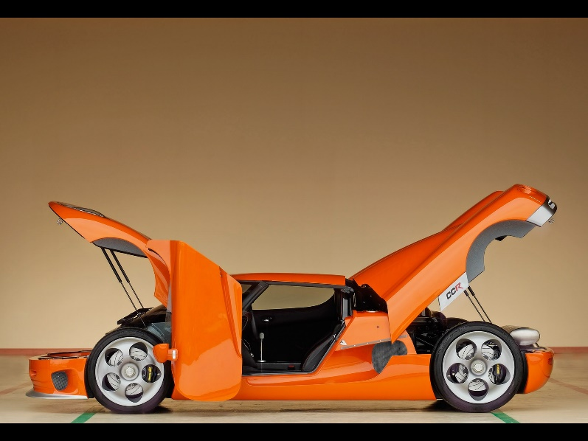
Figure 1. Flush left, normal font settings, sentence case, and ends with a period.
In addition, table captions are placed above the table and have a return after the table number. The second line of the caption provided the description. Note, there is a difference between a return and enter. A return is accomplished with the shortcut key shift + enter. Last, unlike the caption for a figure, a table caption does not end with a period, nor is there a period after the table number.

Table 1
The Word Table and the Table Number are Normal Font and Flush Left. The Caption is Flush Left, Italicized, Uppercase and Lowercase
Level of heading | Format
1 | Centered, Boldface, Uppercase and Lowercase Heading
2 | Flush Left, Boldface, Uppercase and Lowercase
3 | Indented, boldface lowercase paragraph heading ending with a period
4 | Indented, boldface, italicized, lowercase paragraph heading ending with a period.
5 | Indented, italicized, lowercase paragraph heading ending with a period.

References
There are no sources in the current document.

